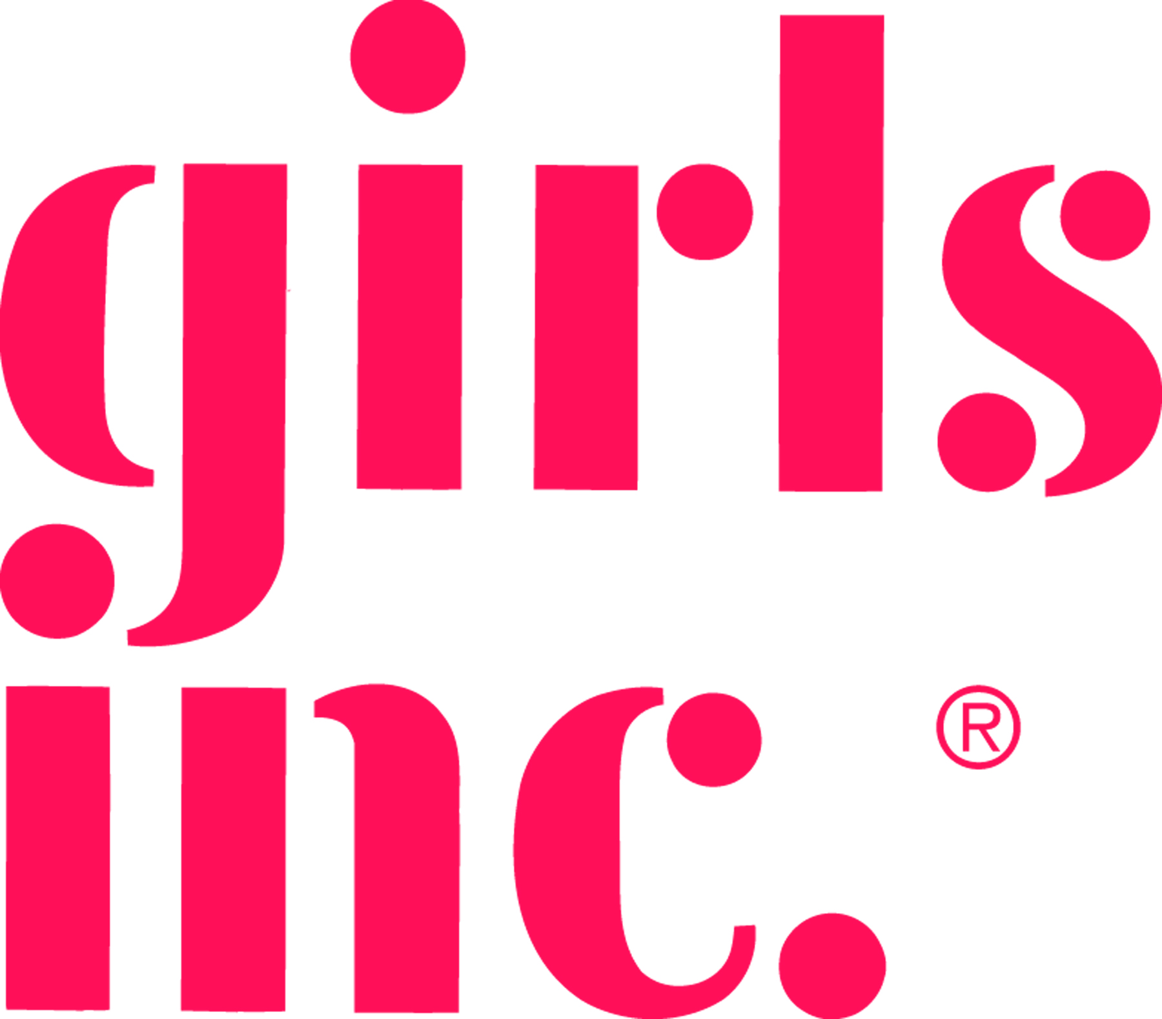
Girls Incorporated of Metropolitan Dallas
Position Description
Title: Van Driver
Reports to: Property Manager
Agency: The mission of Girls Incorporated of Metropolitan Dallas is to inspire all girls to be Strong, Smart and BoldSM. Girls Inc. is the champion for all girls and young women, ages six to 18, that for over 40 years has provided effective life skills and enrichment programs to empower girls daily to take charge of their lives. We provide learning and development opportunities designed around personal effectiveness, academics, and career planning so that girls are inspired to be strong, smart and bold and lead successful, independent and fulfilling lives.

Brief Job Description: : Responsible for safely picking girls up at school, delivering them to the campus, taking them on field trips and returning them to their homes. The position is also responsible for maintaining the assigned van.
Essential Functions
- Provides transportation and maintains vehicles by
- Picking up of girls from school and dropping them off at home
- Driving girls to field trips
- Making sure vans are maintained, fueled, and clean
- Check the van each day for gas, oil, water, and cleanliness (inside and out).

- Maintain girls’ safety while they are on the van
  - Insuring each girl is wearing a seat belt.
  - All procedures for getting on and off the van are followed, that all van passenger rules are followed, and that there are no dangerous disruptions.

- Report any problem with the van’s functioning to supervisor immediately.

- Keep daily van logs listing mileage, gas usage, minor maintenance, etc. and turn logs and gasoline receipts in when designated by supervisor.

- In the event of an accident, see to the girls’ safety first then fill out the appropriate forms and notify the designated staff members, etc.

- Other relevant duties as assigned.

Position Description
Van Driver
Page 2

Machines, Tools, Equipment: Fifteen Passenger Van/mini-buses, Phone, Fax, Printers, Computers and Copiers

Computer Software: Microsoft Office Programs

Qualifications: High School Diploma; 1+ year of relative experience and excellent driving record

Hours: 20 per week

Interview Process: Candidates who meet the above criteria should submit a cover letter detailing their success in the above areas, salary requirements and their resume to employment@girlsincdallas.org; or by mail to: Girls Inc. of Metropolitan Dallas, Attn: Employment Opportunities, 2040 Empire Central Drive, Dallas, TX 75235. Candidates deemed best qualified based on the above requirements will be contacted for a screening interview; those selected will proceed to face-to-face interviews, including individual and team meetings. The organization will move quickly to fill this key opportunity.

